**Healthcare**

**Case Study: Advancing Healthcare Analysis through Data Insights**

**Background**

You are a data analyst at Health Stat Solutions, a company specializing in healthcare analytics. You have been given two datasets: 'Patient Medical Records' and 'Hospital Treatment Details'. The 'Patient Medical Records' dataset contains detailed information on patients, including their age, gender, blood type, diagnosis, treatments, admission and discharge dates, and total bills. The 'Hospital Treatment Details' dataset provides insights into the hospitals treating these patients, including the treating doctor, room number, daily costs, treatment types, and recovery ratings.

In a healthcare industry that relies heavily on data to make informed decisions for patient care and hospital management, your role is crucial. Your task is to analyze these datasets, uncovering trends and insights that could improve patient outcomes and optimize hospital operations.

**Objective**

As an analyst at Health Stat Solutions, your objective is to leverage Power BI for a deep dive into the provided healthcare datasets. This task encompasses meticulous data cleaning and sophisticated data modelling , utilizing DAX for advanced analytics. Your goal is to create a comprehensive, interactive dashboard in Power BI that presents a cohesive narrative of the healthcare data. This dashboard should serve as a tool to uncover and visualize important trends, such as the interplay between patient demographics and treatment outcomes, cost implications of various medical procedures, and overall hospital performance metrics. Your analysis will provide invaluable insights, aiding healthcare providers in enhancing patient care and operational efficiency, and positioning Health Stat Solutions at the forefront of healthcare analytics.

**1.Analysis of Treatment Costs** : Calculate the total cost of treatment for each patient (consider 'TotalBill' and 'DailyCost'). Which treatments are the most expensive on average?

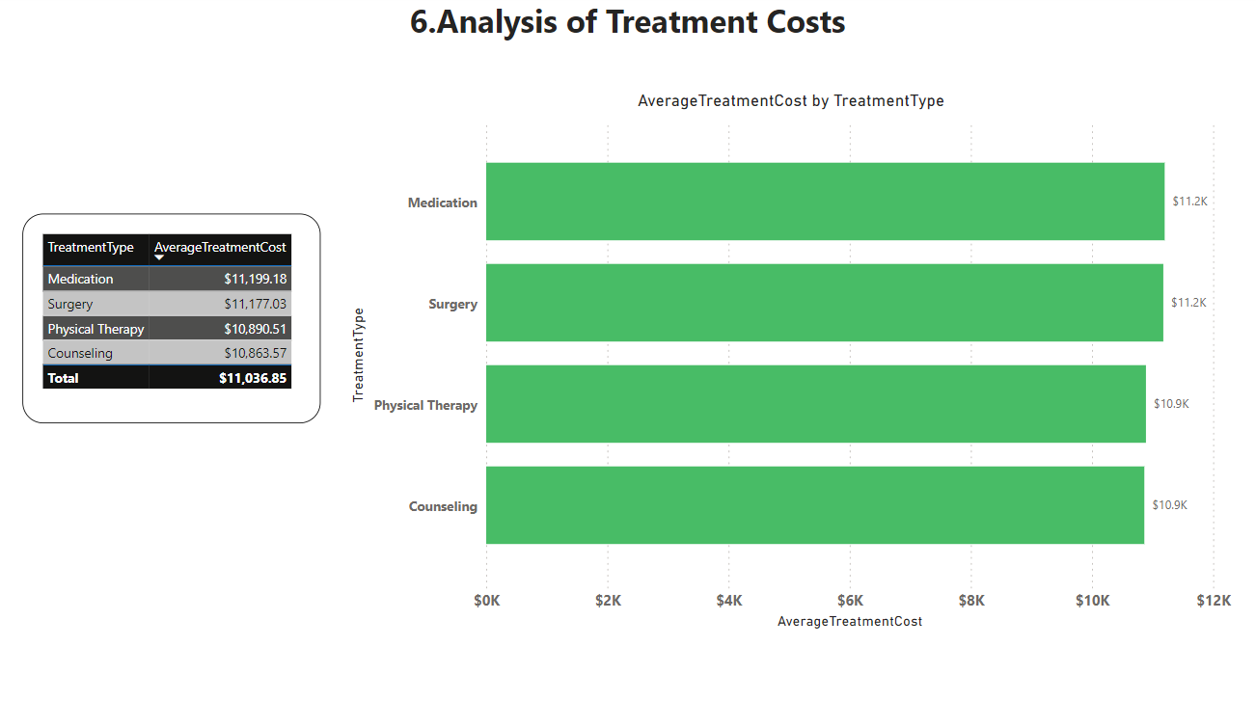**Conclusion:** From the analysis, it is evident that **Medication** is the most expensive treatment type on average cost 11.2k, followed by physical therapy, surgery, and counselling . This information can be valuable for budgeting and resource allocation in healthcare management.

**2.Gender Distribution in Diagnosis** :Analyze the distribution of genders across different diagnoses. Are there any noticeable patterns or trends?

Based on the analysis of the gender distribution across different diagnoses, here are some

**key insights:**

Asthma: Female: 34.98% of asthma cases are in females. This suggests that females have a significant representation in asthma diagnoses but not the majority.

COVID-19: Female: 40.1% of COVID-19 cases are in females.This indicates that COVID-19 has a higher prevalence among females compared to asthma.

Diabetes: Male: 36.06% of diabetes cases are in males. This highlights that diabetes is more prevalent among males compared to other genders.

Other: 40% of cases in the "other" category (which may include non-binary or unspecified genders).This shows a high prevalence of unspecified diagnoses in this group, suggesting a need for targeted medical attention.

**Summary:**

Significant Female Representation: Both asthma and COVID-19 have a considerable percentage of female patients, with COVID-19 being more prevalent among females compared to asthma. Male Prevalence in Diabetes: Diabetes is more common among males, indicating a gender-specific trend for this condition. High Prevalence in 'Other' Category: The 'other' category shows a high percentage for unspecified diagnoses, which might need further investigation.

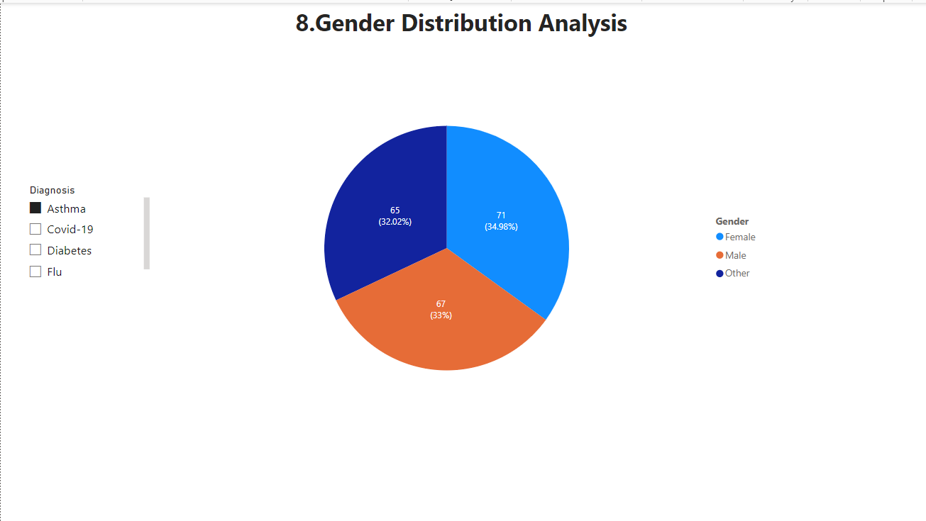

**3.Blood Type Analysis** : Investigate the distribution of blood types among the patients. Is there a blood type that is more prevalent?

**Key Insights:**

Most Prevalent Blood Types: AB+ and B- have the highest prevalence among the patients, both at 13.5%. This suggests that these blood types are more common in the patient population.

Moderately Prevalent Blood Types: A+ (13.1%) and A- (12.9%) are also relatively common, indicating a significant representation among patients. B+ (12.8%) and AB- (12.4%) follow closely, showing moderate prevalence.

Less Prevalent Blood Types: O- (11.7%) and O+ (10.1%) are the least common blood types in the dataset.

**Actionable Insights:**

Resource Allocation: Given the higher prevalence of AB+ and B- blood types, healthcare facilities may need to ensure an adequate supply of these blood types for transfusions and other medical needs.

Awareness Campaigns: Awareness campaigns can be tailored to encourage donations from individuals with less common blood types, such as O+, to maintain a balanced blood bank.

These insights can help in improving healthcare planning, resource allocation, and patient care based on the prevalence of different blood types among the patient population.

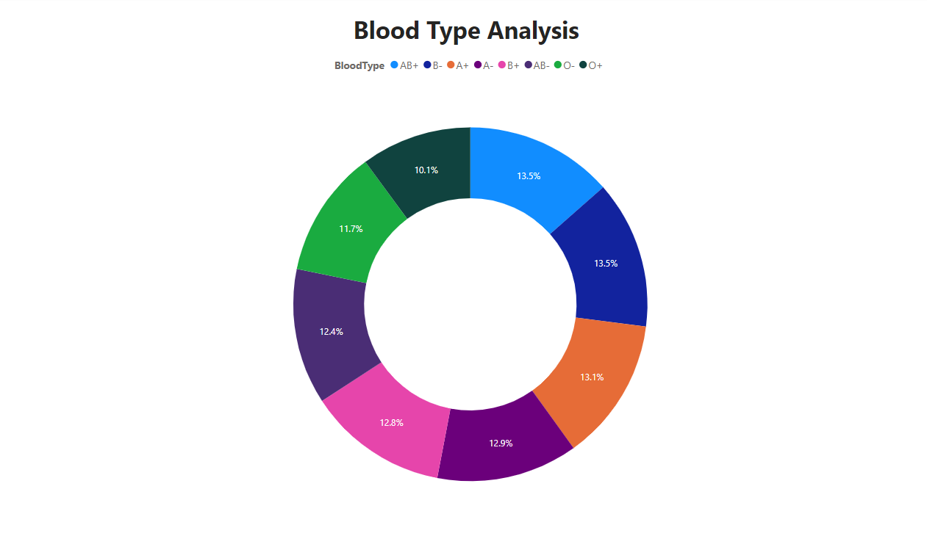

**5.Recovery Rating Analysis** : Analyze the average recovery rating by treatment type. Which treatment type has the highest average recovery rating?

**Average Recovery Ratings by Treatment Type:**

Counseling: 5.6

Medication: 5.5

Physical Therapy: 5.4

Surgery: 5.2

**Key Insights:**

Counseling has the highest average recovery rating at 5.6. This suggests that patients who undergo counseling report the highest satisfaction or perceived recovery.

Surgery has the lowest average recovery rating at 5.2, suggesting that patients perceive this treatment type as less effective compared to the others, or it could indicate a more challenging recovery process.

**Actionable Insights:**

Expand counseling services to more patients to improve satisfaction and recovery outcomes.

Maintain or improve current medication protocols to further enhance patient outcomes.

Explore new techniques or approaches to boost the effectiveness of physical therapy.

Improve post-operative care and patient education to better support surgical recovery.

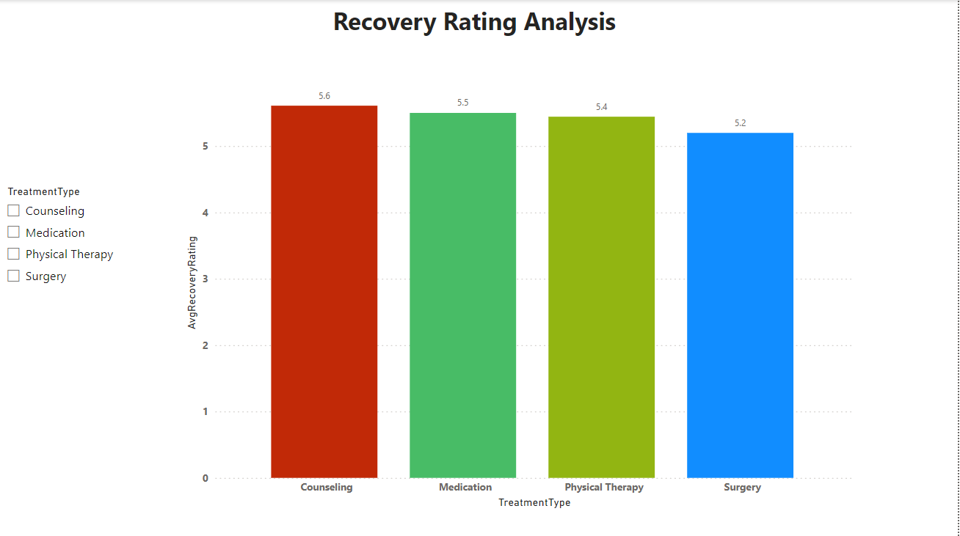

6. **Hospital Utilization Analysis** : Calculate the average number of patients per room in each hospital. Which hospital has the highest utilization?

**Conclusion:**

Based on the Hospital Utilization Analysis, the average number of patients per room has been calculated for each hospital. **Green Valley Medical Center** emerges with the highest utilization, with an average of **1.36 patients per room**. This indicates a significant occupancy rate, suggesting efficient utilization of resources at Green Valley Medical Center.

**Insights:**

Utilization Disparity: The analysis reveals significant differences in hospital utilization rates, with some facilities experiencing higher patient-to-room ratios than others.

Efficiency Metrics: Understanding the average number of patients per room provides valuable insights into how efficiently hospital resources are utilized. Higher ratios indicate better resource optimization and potentially higher patient throughput.

Operational Implications: Hospitals with higher utilization rates may need to adapt their operational strategies to manage patient flow, optimize room turnover, and ensure quality care delivery amidst increased demand.

Capacity Planning: Identifying hospitals with lower utilization rates could indicate underutilized capacity, presenting opportunities for resource reallocation or service expansion to meet patient needs effectively.

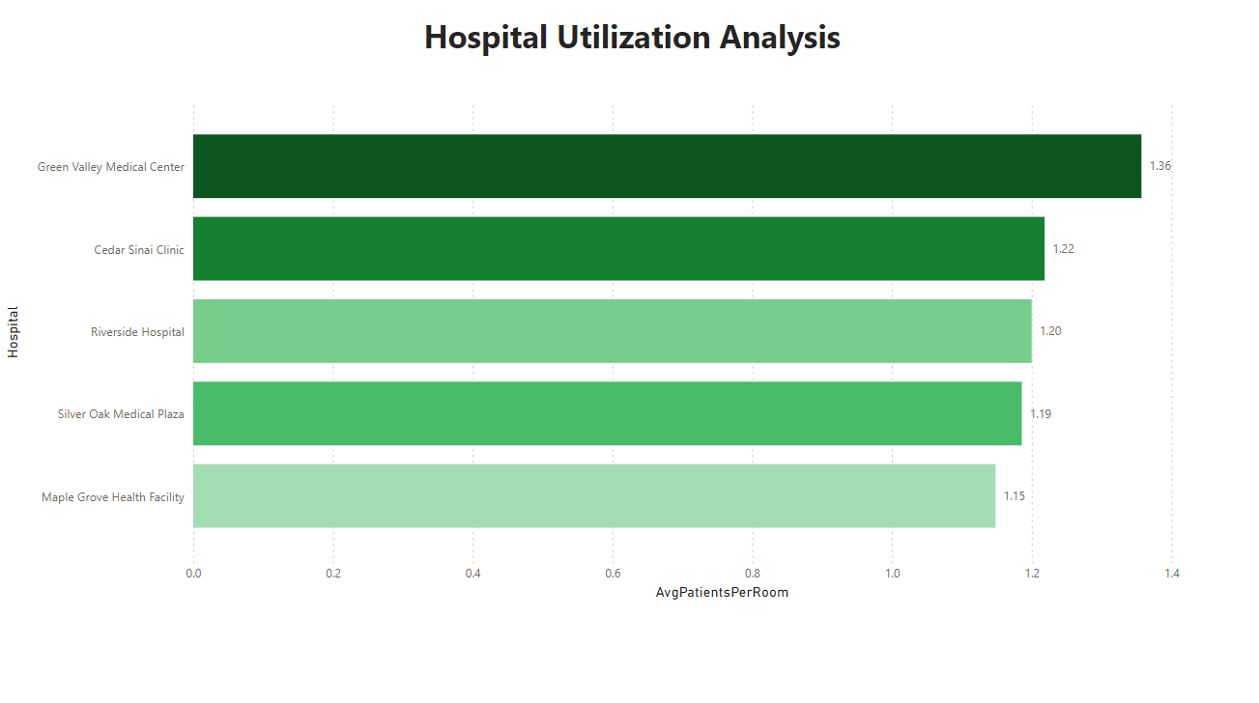

**7.Doctor's Patient Load** : Analyze which doctor has treated the most patients. Does a higher patient load correlate with lower recovery ratings?

**Conclusion:**

Based on the analysis of Doctor's Patient Load, it appears that Dr. David Moore has treated the most patients, with a count of 8 patient IDs. Interestingly, despite having a higher patient load, **Dr. Moore's average recovery rating is 6.75.**

This indicates that there isn't a clear correlation between a doctor's patient load and lower recovery ratings. In Dr. Moore's case, despite seeing a higher number of patients, the average recovery rating remains relatively high.

**Key Insights:**

Patient Satisfaction: High recovery ratings for Dr. Moore despite a higher patient load may indicate effective time management, communication, and treatment strategies that contribute to positive patient experiences.

Recovery Ratings: Despite having a higher patient load, Dr. Moore maintains a relatively high average recovery rating of 6.75. This suggests that a higher patient load doesn't necessarily correlate with lower recovery ratings for all doctors.

Quality of Care: The recovery ratings provide insights into the quality of care provided by each doctor, reflecting patient satisfaction and treatment effectiveness.

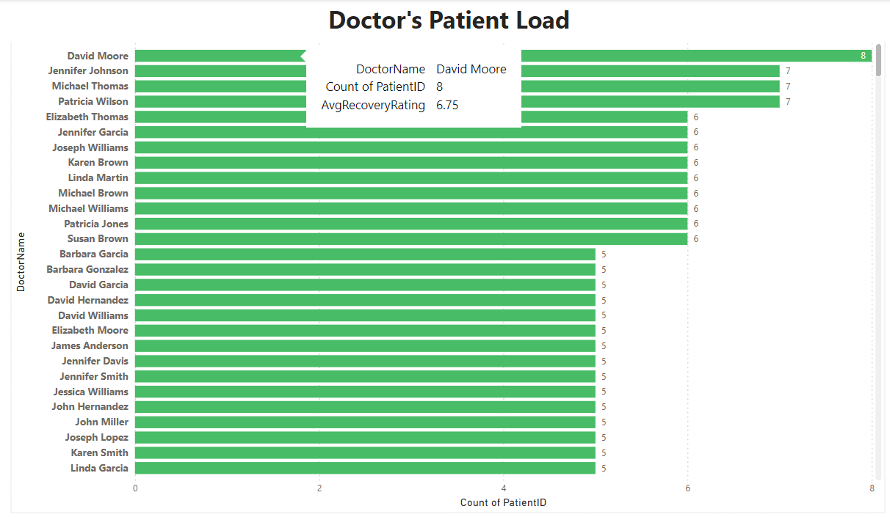Individual Performance: Each doctor's ability to manage their patient load while maintaining quality care and high recovery ratings may vary, indicating differences in skill, efficiency, and patient management techniques.

8. **Treatment Effectiveness** : Compare the length of stay against the recovery rating for different treatment types. Which treatment shows the most effectiveness?

**Conclusion:**

Counseling services have the highest recovery rating of 5.61, with a count of 6.61. The average length of treatment remains constant for all cases.

**Key Insights:**

Effectiveness Assessment: The data suggests that counseling services demonstrate the most effectiveness in terms of recovery rating relative to length of stay. Despite the short duration of treatment, patients undergoing counseling exhibit notably high recovery ratings.

Optimal Treatment Duration: The findings imply that for certain conditions or patient populations, shorter treatment durations, such as those associated with counseling services, may yield significant improvements in recovery outcomes.

Quality of Care: The high recovery ratings associated with counseling services underscore the importance of tailored and specialized interventions in promoting patient well-being and recovery.

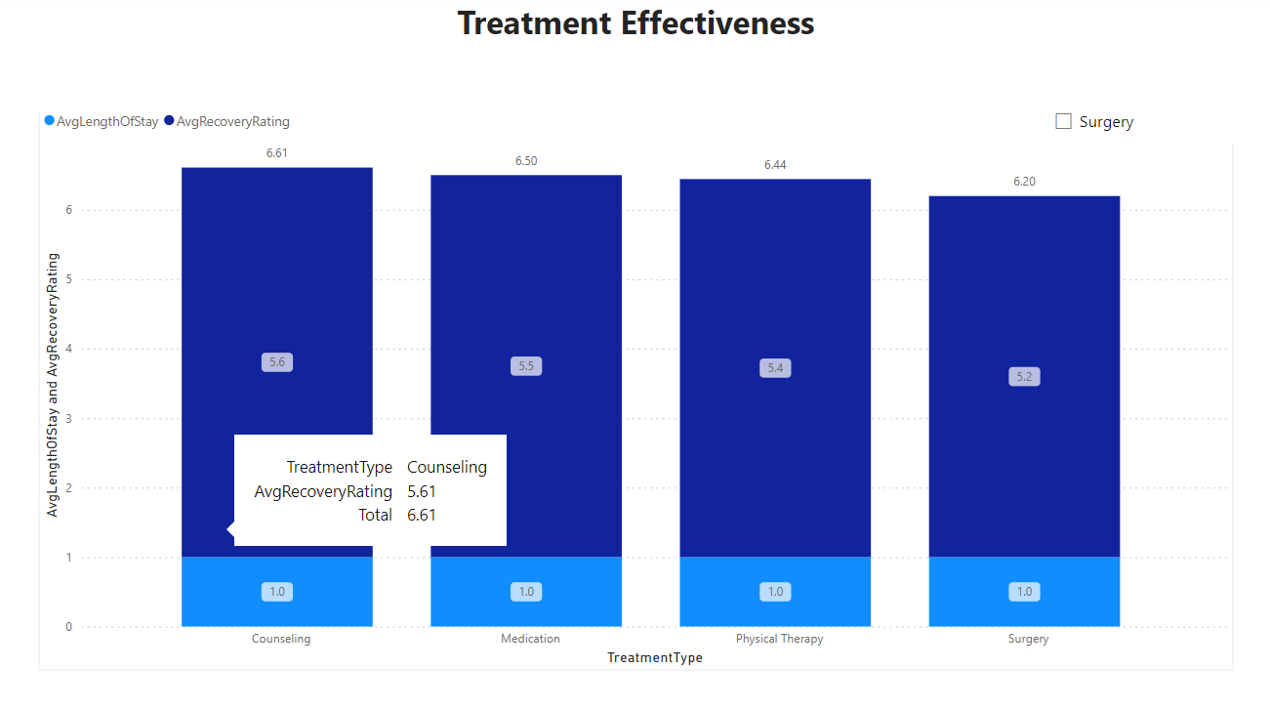

**9.Cost Analysis by Hospital** :Investigate the average treatment cost per patient in each hospital. Which hospital has the highest and lowest costs?

**Key Insights:**

Cost Disparity: There is a significant variation in average treatment costs per patient across hospitals.

Highest Cost: Cedar Sinai Clinic has the highest average treatment cost at $11.3K per patient.

Lowest Cost: Riverside Hospital has the lowest average treatment cost at $0.6K per patient.

**Conclusion:**

The analysis reveals notable differences in treatment costs among hospitals, with Cedar Sinai Clinic being the most expensive and Riverside Hospital the most cost-effective. This information can guide financial planning and resource allocation for both patients and healthcare administrators.

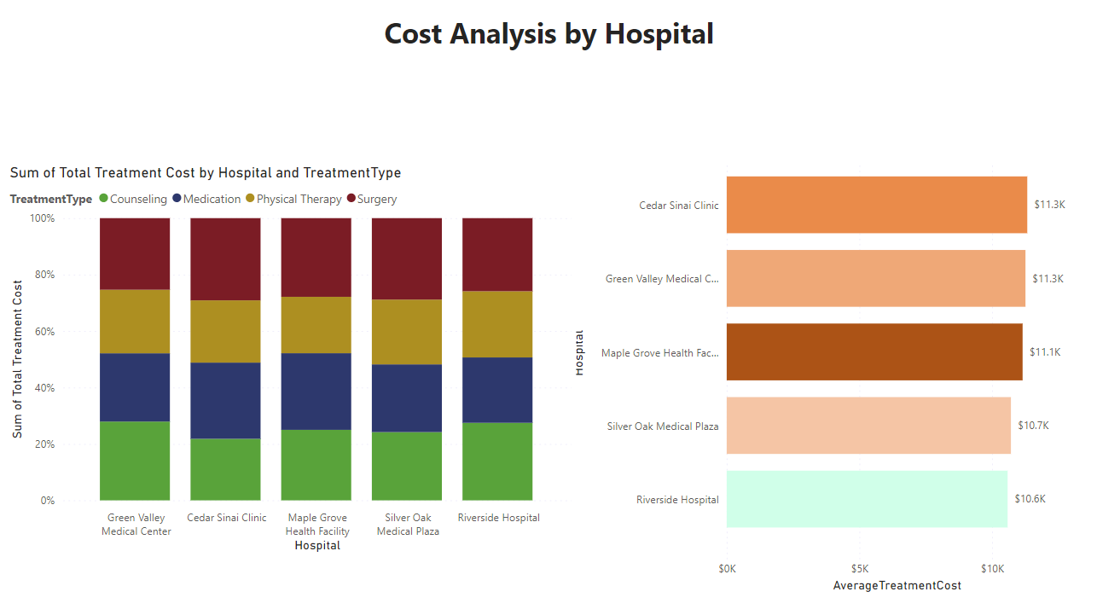

10.**Patient Admission Trends Over Time** :Analyze the trends in patient admissions over time. Are there any seasonal patterns?

**Key Insights:**

Increasing Trend: From January to August, there is a steady increase in patient admissions across all treatment types.

Peak in June Admissions peak in June for every treatment type.

Decreasing Trend: After August, there is a noticeable decline in patient admissions, continuing through to December.

**Actionable Insights:**

Resource Allocation: Increase staffing and resource availability during the peak period (January to August) to accommodate the higher patient load.

Capacity Management: Plan for reduced demand from September to December by adjusting resource allocation, scheduling maintenance, or offering staff training during the quieter months.

Seasonal Promotions: Implement targeted promotions or wellness programs in the off-peak period to balance patient admissions and utilize available capacity effectively.

Preventive Measures: Analyze potential causes for the seasonal decline and introduce preventive health measures or outreach programs earlier in the year to maintain a steadier patient admission rate.

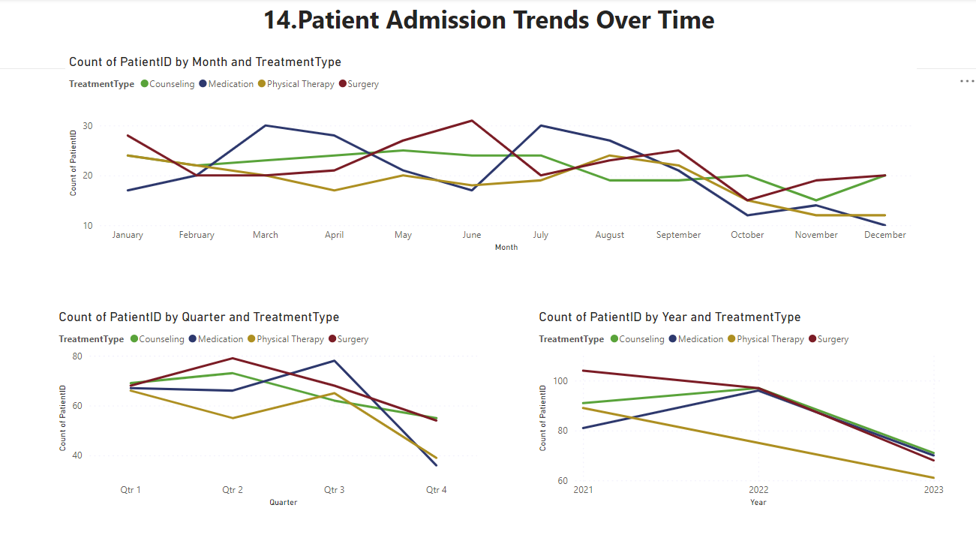

11. **Correlation Between Age and Recovery** :Explore if there's a correlation between patient age and recovery rating.

**Key Insights:**

Age Groups and Correlation:

For adults, there is a weak positive correlation of 0.08 between patient age and recovery rating.

Seniors show a slightly stronger positive correlation of 0.11 between age and recovery rating.

Children exhibit the lowest correlation of 0.06 between age and recovery rating.

**Actionable Insights:**

Elderly Care: Given the stronger correlation among seniors, prioritize personalized care and support for older patients to enhance recovery outcomes.

Pediatric Care: Despite the lower correlation among children, ensure age-appropriate care and support to optimize recovery and well-being.

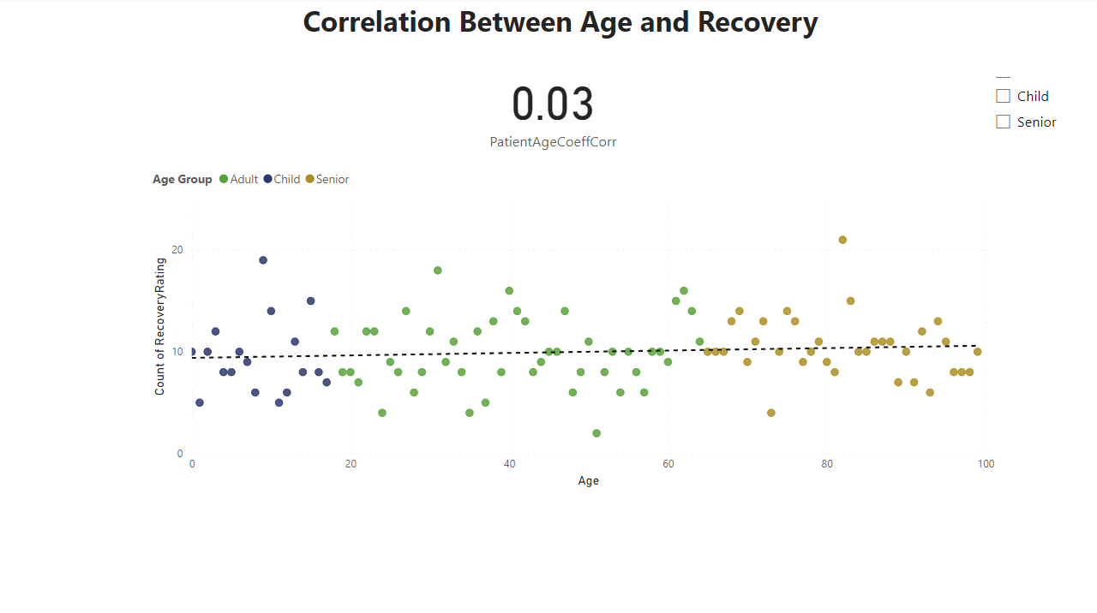

12. **Analyzing Room Efficiency** :Create a measure to analyze the efficiency of room usage (number of patients per room ).

Room Utilization Rate=(Number of Patients/Total Number of Rooms)×100

**Key Insights:**

Efficiency Variation: Green Valley Medical Center exhibits the highest room efficiency at 28.38%, indicating effective utilization of available rooms. In contrast, Riverside Hospital has the lowest efficiency at 17.4%.

Operational Performance: Silver Oak Medical Plaza, Sidar Cinai Clinic, and Maple Growth Health Facility demonstrate moderate room efficiency levels, ranging from 17.8% to 18.46%.

Resource Optimization: Understanding room efficiency helps identify hospitals that may be underutilizing their resources, allowing for targeted interventions to improve operational effectiveness.

**Actionable Insights:**

Capacity Planning: Hospitals with lower room efficiency should review their room allocation strategies and consider reallocating resources to meet patient demand more effectively.

Process Optimization: Implement streamlined processes for room turnover and patient flow management to maximize room utilization without compromising patient care quality.

Staff Training: Provide staff training on efficient room utilization practices and resource management to ensure optimal use of available infrastructure.

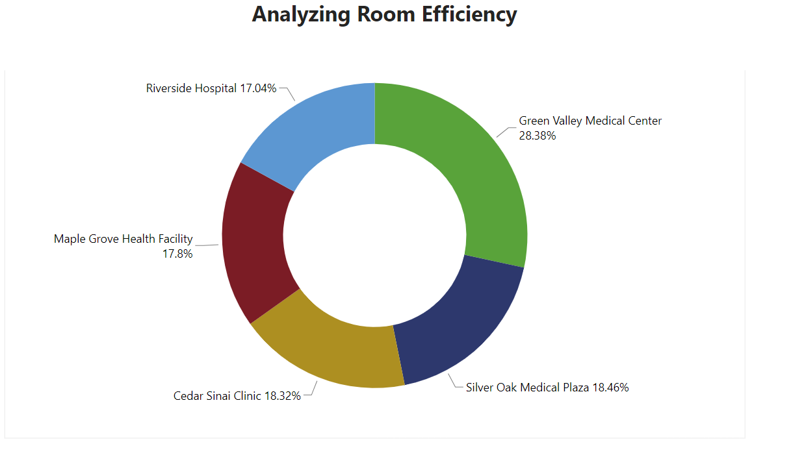

13. **Impact of Doctor on Recovery** :Analyze if the treating doctor has a significant impact on the patient's recovery rating.

**Key Insights:**

Doctor's Influence: The analysis indicates that the treating doctor has a notable impact on the patient's recovery rating. The top 7 doctors all achieved an average recovery rating of 10.17, suggesting a strong positive correlation between doctor performance and patient outcomes.

Consistency in Performance: The fact that the top 7 doctors consistently achieved high recovery ratings across all patients underscores the importance of physician expertise, care quality, and treatment effectiveness in influencing recovery outcomes.

**Actionable Insights:**

Best Practices Identification: Analyze the practices and approaches of the top-performing doctors to identify best practices and strategies that contribute to high recovery ratings. Share these insights with other medical staff to enhance overall patient care.

Patient-Centered Care: Emphasize patient-centered care approaches that prioritize individual patient needs, preferences, and treatment goals. Encourage doctors to engage patients in shared decision-making and personalized treatment planning to enhance patient satisfaction and outcomes.

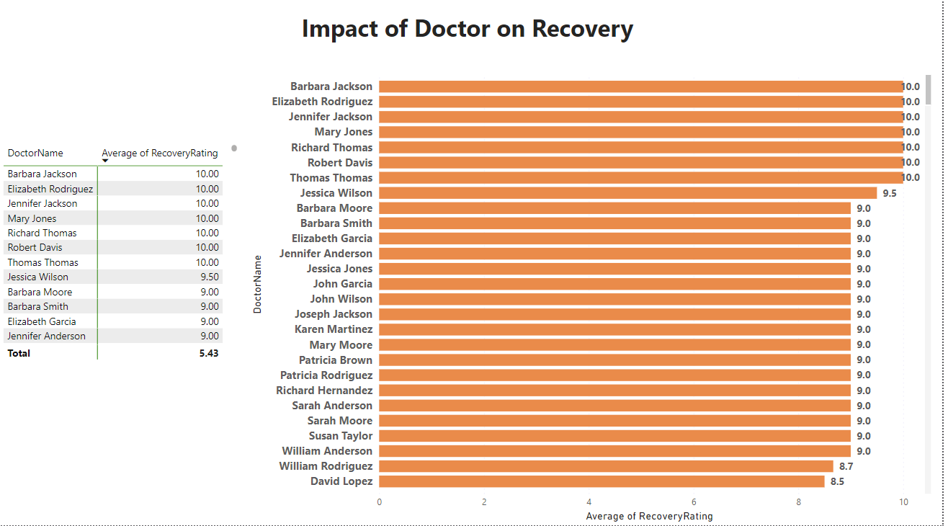

14.**Length of Stay and Cost Correlation** :Explore the correlation between the length of stay and total treatment cost.

**Insights:**

Treatment Cost Variation: Among the analyzed treatments, medication incurs the highest treatment cost, amounting to $11.224k, followed by therapy at $11.013k, and surgery at $10.852k.

Consistent Length of Stay: Across all treatment types, there is a consistent average length of stay, approximately 1 Unit.

**Actionable Insights:**

Cost Efficiency Measures: Explore cost-saving measures for treatments with higher costs, such as medication, without compromising patient care quality.

Resource Allocation: Optimize resource allocation based on the consistent length of stay across treatments, ensuring efficient use of facilities and personnel.

Outcome Analysis: Further investigate the factors contributing to treatment costs and their relationship with patient outcomes to identify areas for improvement and cost reduction opportunities.

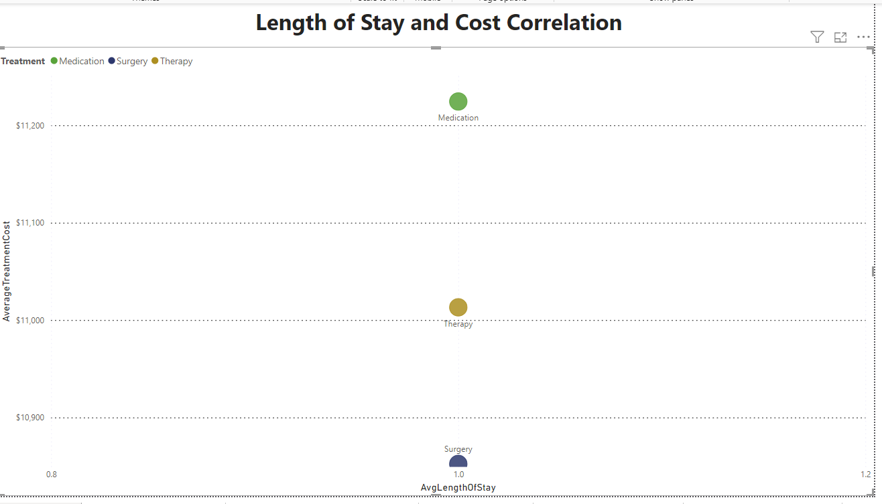

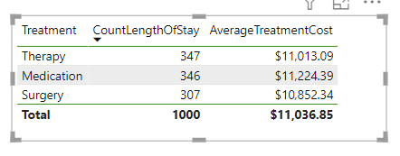

15. **Recovery Trends by Gender and Age Group** : Analyze recovery trends across different genders and age groups.

**Insights:**

**Gender-Based Trends:**

Female adults have the highest average recovery rating at 919.00, indicating better recovery outcomes compared to other gender-age groups.

Male children follow with an average recovery rating of 314, suggesting lower recovery outcomes compared to female adults.

Further analysis is needed to understand the factors contributing to these gender-based differences in recovery trends.

**Age-Based Trends:**

Other seniors exhibit a relatively high average recovery rating of 704.80, indicating favorable recovery outcomes among this age group.

Male children have the lowest average recovery rating, implying potential challenges or unique considerations in pediatric care.

**Actionable Insights:**

Enhanced Pediatric Care: Allocate resources and implement targeted programs to address the unique needs of male children, potentially improving their recovery outcomes.

Geriatric Care Focus: Focus on enhancing care quality and support services for other seniors to maintain or improve their favorable recovery trends.

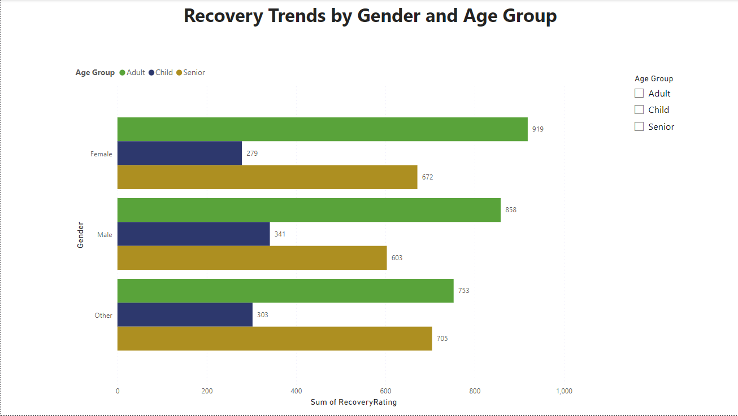

16. **Hospital Performance Analysis** :Create a comprehensive performance analysis for each hospital, considering factors like patient load, recovery ratings, and treatment costs.

**Key Insights:**

**Green Valley Medical Center** stands out with the highest patient count, indicating a significant demand for services. However, it has a slightly lower average recovery rating of **5.3** compared to other hospitals.

Riverside Hospital demonstrates the highest average recovery rating of 5.6, showcasing effective patient care and treatment outcomes, despite a moderate patient count.

Cedar Sinai Clinic and Maple Grove Health Facility exhibit the highest treatment costs at $11.3k, suggesting potential opportunities for cost optimization while maintaining quality care.

Silver Oak Medical Plaza and Riverside Hospital have relatively lower treatment costs compared to Cedar Sinai Clinic and Maple Grove Health Facility, indicating efficient resource utilization.

**Actionable Insights:**

Quality Improvement: Identify and implement best practices from Riverside Hospital to improve recovery outcomes across all hospitals.

Cost Optimization: Explore opportunities for cost optimization at Cedar Sinai Clinic and Maple Grove Health Facility without compromising patient care quality.

Capacity Management: Develop strategies to manage patient load effectively at Green Valley Medical Center, ensuring timely and quality care delivery.

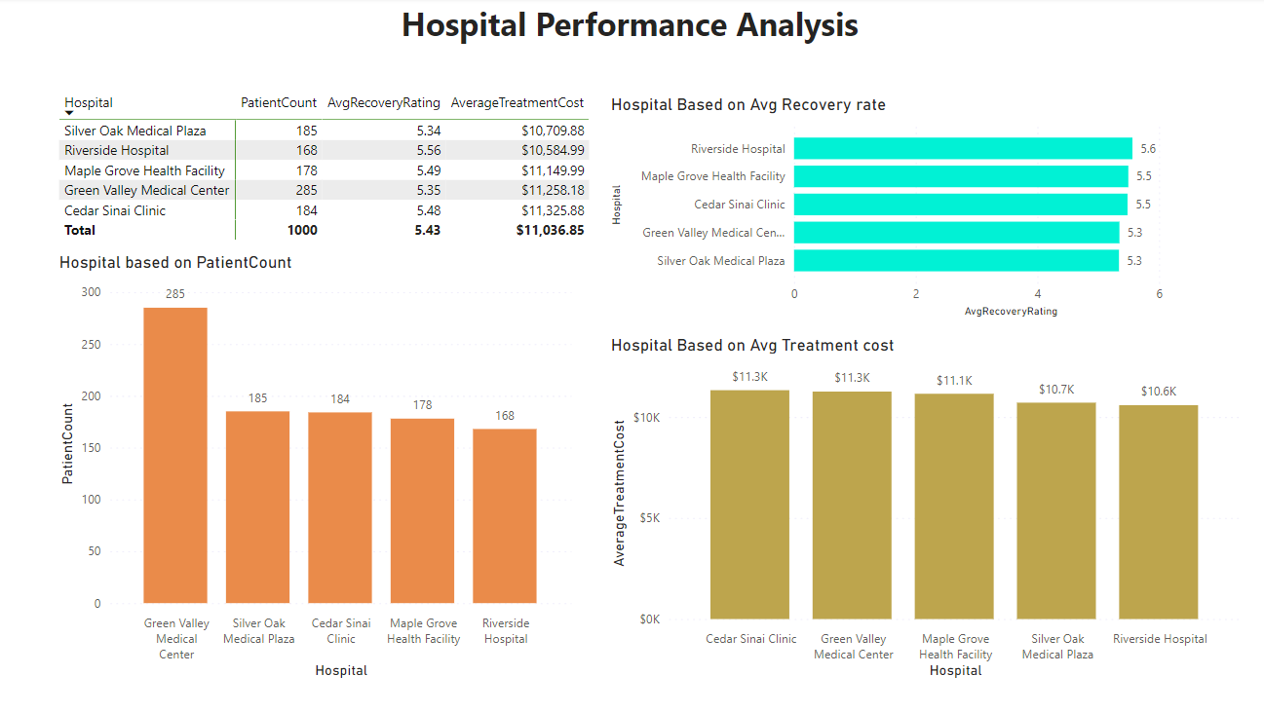

**17**.**Extracting Key Information** :Using the 'Full Prescription Details' column in the updated Healthcare Dataset 1, create a new column that lists only the names of the medications and their dosages for each patient. Exclude other details like frequency and duration from this column.

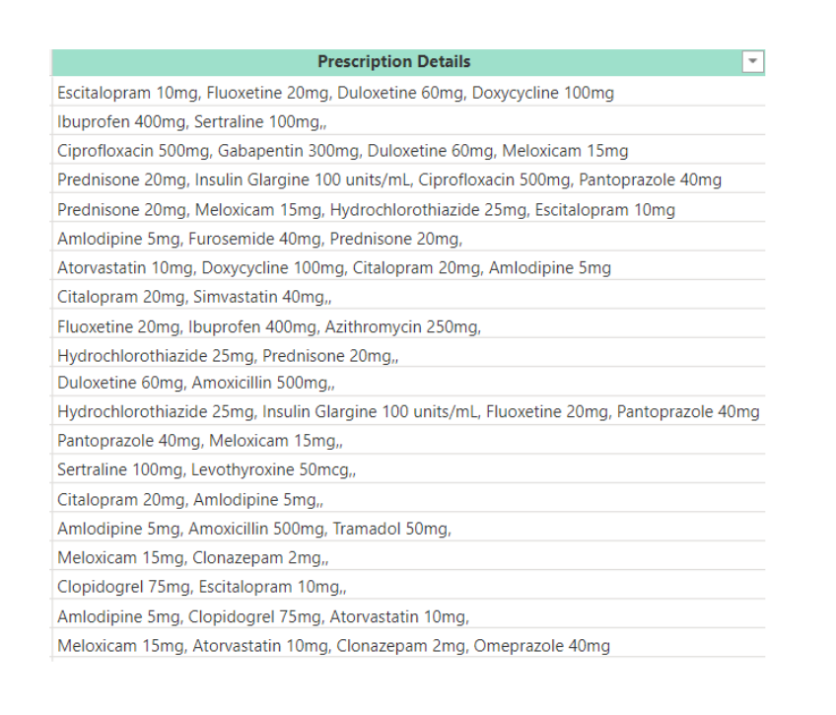

**18. Predictive Modeling for Recovery Rating** :Create a predictive model estimating the recovery rating based on factors like age, diagnosis, and treatment type.

**Trend Analysis:**

Green Valley Medical Center experienced a significant decline from 2021, while Cedar Sinai Clinic had the highest average total bill, diverging from recovery ratings.

**Predictive Modeling:**

hospitals can create predictive models to estimate recovery ratings based on factors like age, diagnosis, and treatment type, enabling better decision-making and resource allocation.

**Actionable Insights:**

Performance Evaluation: Regularly evaluate hospital performance to identify improvement areas.

Data-Driven Decision Making: Use advanced analytics for informed decision-making and resource optimization.

Continuous Improvement: Foster a culture of continuous improvement to enhance patient care and operational efficiency.

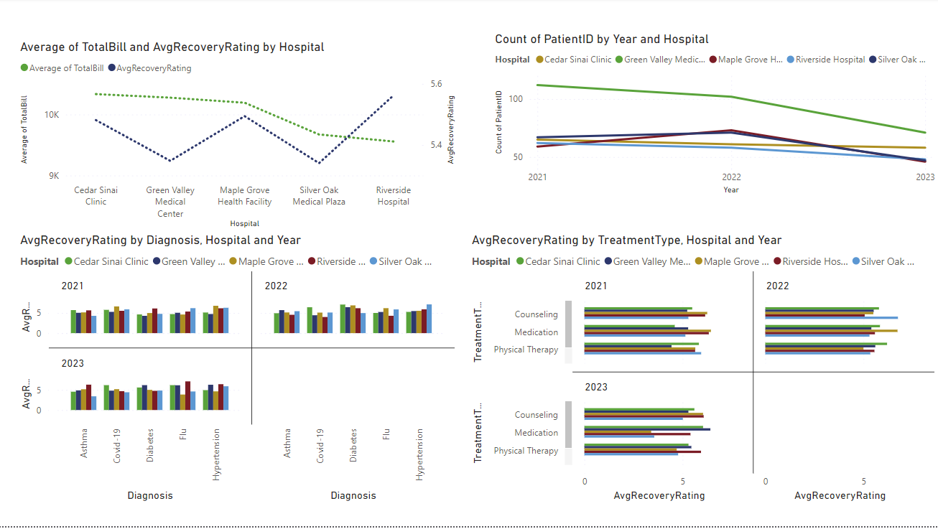

**19.Data Modeling: Cohort Analysis Based on Admission Date** : Perform a cohort analysis of patients based on their admission date. Analyze the recovery ratings and treatment costs for different cohorts.

**Cohort Analysis Based on Admission Date:**

Performing a cohort analysis based on admission date involves grouping patients into cohorts based on the month they were admitted. Here's a summary of the analysis:

**Highest and Lowest Recovery Ratings:**

November (Nov) had the highest average recovery rating at 6.00, representing a 23.88% increase compared to September (Sep), which had the lowest average recovery rating at 4.85.

**Range of Recovery Ratings:**

Across all 12 cohorts, average recovery ratings ranged from 4.85 to 6.00.

**Insights:**

Seasonal Variation: November showed the highest recovery ratings, suggesting potential seasonal influences on recovery outcomes. Further investigation into seasonal factors impacting patient recovery could be beneficial.

